[**Project Title: Mern Training Center**](https://citria.org/)

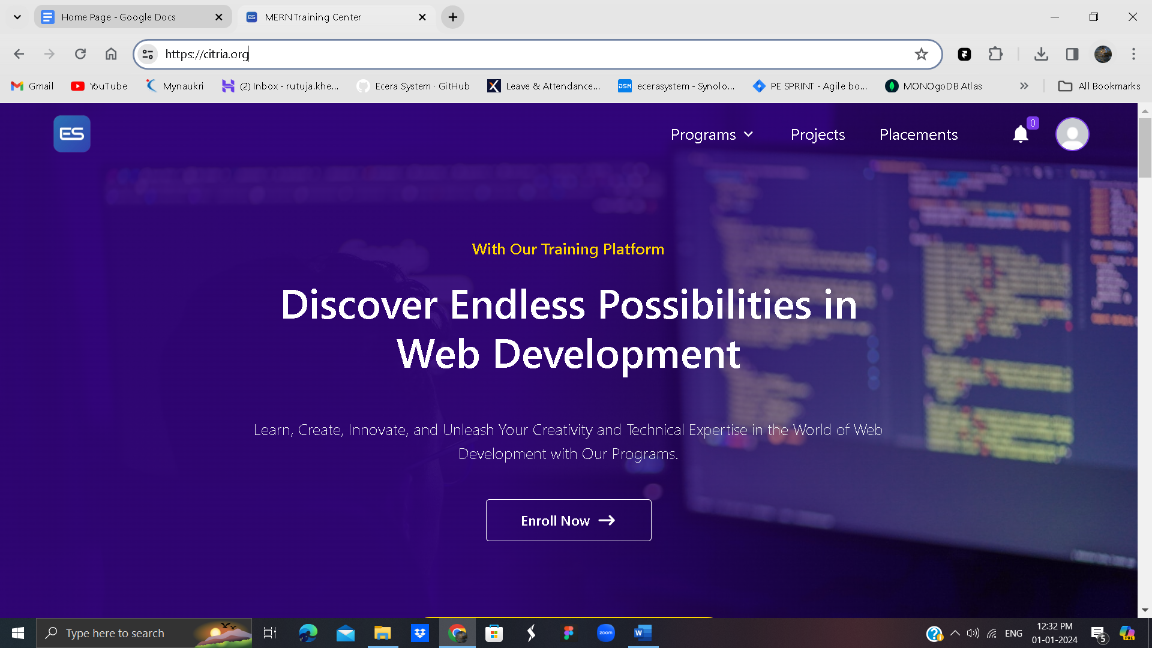

Citria.org is a training platform owned by Ecera System.

The **HeroSection** component is a React component that represents a hero section on a web page. It includes various elements such as a background image, a gradient overlay, and dynamic content. The component is designed to be visually appealing and engaging, typically used at the top of a webpage to capture the user's attention.

1. Component Structure and Dependencies

The HeroSection component utilizes several external dependencies and libraries:

React: The core React library for building user interfaces.

react-icons (HiArrowNarrowRight, BsArrowLeft, BsArrowRight): Icon components used for arrow navigation.

PropTypes: A library for defining and enforcing prop types in React components.

axios: A library for making HTTP requests, used here to fetch review data.

Slider (react-slick): A carousel component for displaying a slider of reviews.

2. Component Features

2.1 Mousemove Effect

The component includes a mousemove effect that dynamically changes the background gradient based on the user's mouse movement. This feature enhances the visual appeal of the hero section.

2.2 Review Data Fetching

The component makes an asynchronous request to 'review_data.json' using Axios to fetch review data. The received data is then used to populate the reviews slider.

2.3 Slider Configuration

The reviews are displayed in a slider/carousel using the react-slick library. The slider is configured with settings for responsiveness and navigation arrows.

2.4 Styling with Tailwind CSS

The component uses Tailwind CSS for styling, making it easy to create a responsive and visually appealing layout.

**Book a counseling**

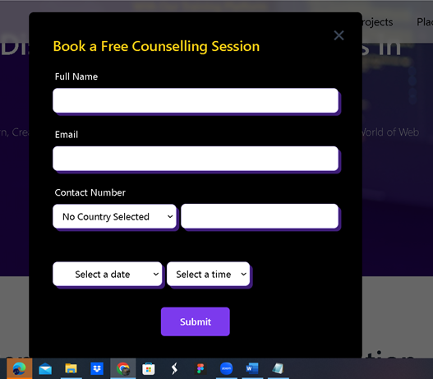

The BookAFreeCounselling component is a React component responsible for handling the booking of free counseling sessions on a web page. It provides a button to initiate the booking process, a modal for entering user details, and dynamic form validation for a seamless user experience.

1. Component Structure and Dependencies

The BookAFreeCounselling component depends on the following external libraries and components:

React: The core React library for building user interfaces.

react-icons (HiArrowNarrowRight, IoCloseSharp, RiErrorWarningFill): Icon components used for button arrows, closing the modal, and displaying error warnings.

contextProvider: A context provider for accessing shared state, such as displaying toasts.

2. Component Features

2.1 Booking Button

The component renders a button that, when clicked, triggers the modal for booking a free counseling session.

2.2 Modal for Booking

The modal is displayed when the user clicks the booking button. It allows users to enter their name, email, contact number, and select date and time slots for the counseling session.

2.3 Dynamic Form Validation

The component dynamically validates user input for the form fields and provides error messages accordingly. It checks for the presence of required fields, valid email format, valid contact number, and ensures that at least one date and time slot is selected.

2.4 Success Notification

Upon successful submission of the counseling session booking, a success notification is displayed, and the modal is closed after a specified duration.

3. Usage

The BookAFreeCounselling component can be used within a larger React application by importing and rendering it. It provides a user-friendly interface for booking counseling sessions.

After counseling is booked successfully the following message will be displayed



**Success Stories https://citria.org/placements**

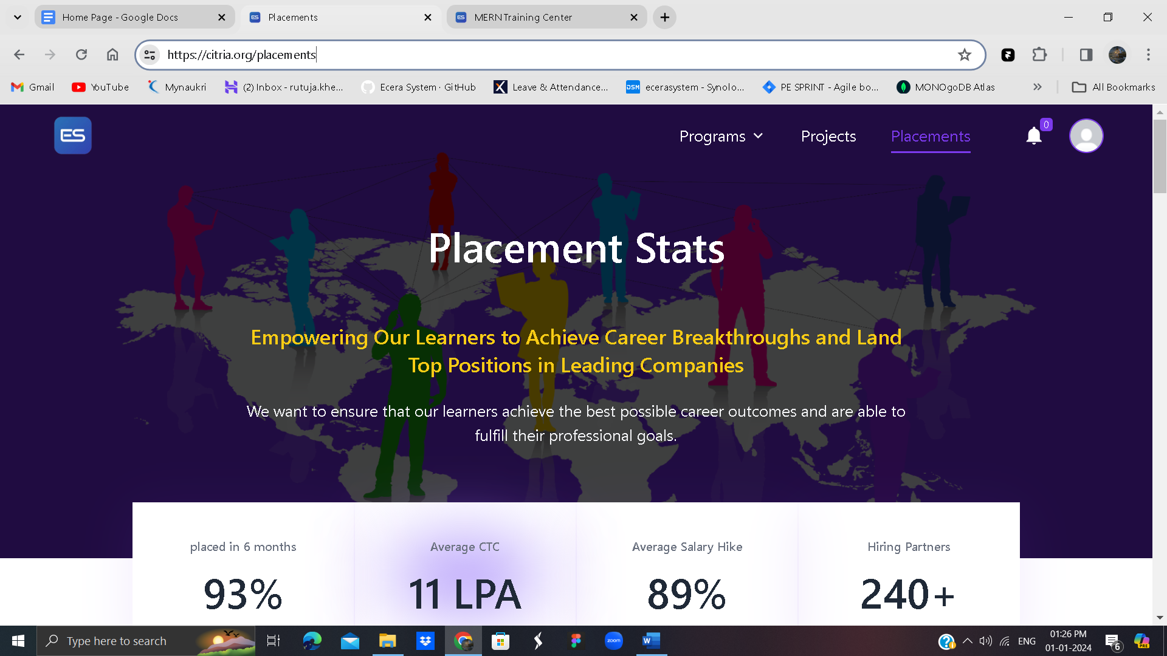

The SuccessStories component is a React component designed to showcase success stories or testimonials from students who have benefited from educational programs. It utilizes the react-slick library to create a carousel/slider for an interactive and visually appealing presentation of student reviews.

1. Component Structure and Dependencies

The SuccessStories component depends on the following external libraries and components:

axios: A library for making HTTP requests, used here for fetching student review data.

React: The core React library for building user interfaces.

react-icons (BsArrowLeft, BsArrowRight): Icon components used for customizing navigation arrows in the slider.

Slider (from react-slick): A React-based carousel/slider component that allows easy configuration and customization of slides.

2. Component Features

2.1 Data Fetching

The component uses the axios library to fetch student review data from the 'review_data.json' file. This data is used to dynamically populate the slider.

2.2 Slider Configuration

The react-slick library is utilized to configure the slider's behavior. It supports infinite scrolling, lazy loading, and other customization options such as slide speed and the number of slides to show at once.

2.3 Dynamic Slide Rendering

The success stories are dynamically rendered based on the fetched data. Each slide contains information about a student, including their avatar, feedback, name, position, and company.

3. Usage

The SuccessStories component can be integrated into a larger React application by importing and rendering it. It provides a visually appealing way to showcase success stories.

**TechIcon**

The `TechIcon` component is designed to display a slider of technology icons, each associated with a title. It utilizes the `react-slick` library for creating a responsive and dynamic slider.

## Usage

To use the `TechIcon` component, follow these steps:

1. Import the `TechIcon` component:

import TechIcon from './path/to/TechIcon';

Include the TechIcon component in your JSX:

Copy code

<TechIcon />

Props

The TechIcon component does not accept any external props. However, it comes with predefined settings for the slider, as specified in the component code.

Internal Structure

The component internally uses the Slider component from the react-slick library. It takes an array of technology objects (data) with each object containing an image (img) and a title (title). The slider is configured to show 5 items at a time with responsive breakpoints for different screen sizes.

Styling

The component applies styling to ensure a visually appealing display. The icons are enclosed in a rounded container with a shadow effect.